**PDA/EDAs For Retail/Warehousing (uncategorized)**

<https://www.alibaba.com/product-detail/Factory-Inventory-5-Inch-8-Cores_1600498886896.html?spm=a2700.galleryofferlist.normal_offer.d_title.36dc59abPAUBAG>

**Prices:** 1 to 99 pieces US$278.00

100 to 499 pieces US$259.00

500 to 999 pieces US$248.00

>= 1000 units US$239.00

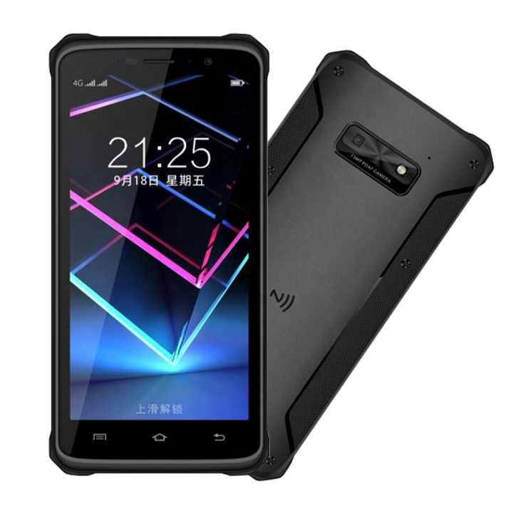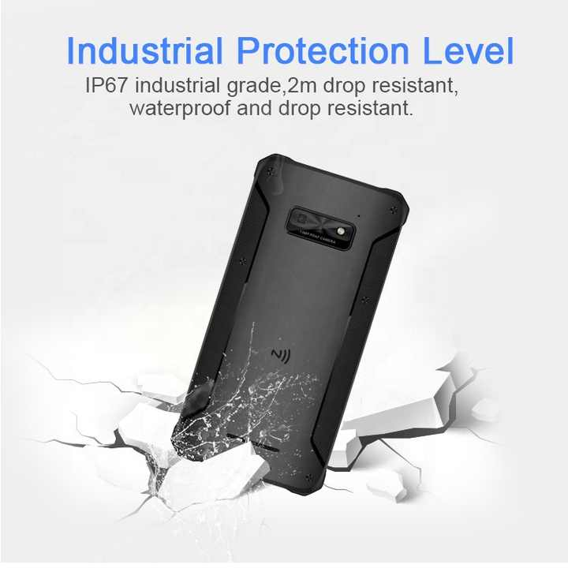

**Product Name:** GAOTek Handheld Logistic PDA

**Product ID:** GAOTek-PERW-208

**Overview:** GAOTek Handheld Logistic PDA has aEquipped with a super 8-core 2.0GHz processor, the CPU performance is improved by 30%compared with the existing mainstream manufacturer brands, and it has an upgraded operating system android9.0, which provides a more stable, smoother and more complete application experience for work ﻿it can accurately and quickly read all kinds of 1d and 2d barcodes. Whether it is stained, old and faded or display on the screen, it can be accurately read.

**Technical Specifications:**

|  |  |
| --- | --- |
| **Processor** | MT6762V or CA (Eight core processor, main frequency 2.0GHz) |
| **Operation System** | Android 9.0 |
| **RAM** | 64 GB ROM+ 4 GB RAM Standard |
| **Expansion Slot** | Micro SD card Maximum support 64GB，SDHC） |
| **Display Screen** | 5.45inch ,720 x 1440, HD+ 18:9，LTPS Technology |
| **Touch Screen** | GFF 10-point touch, glove mode or wet hand operation |
| **Front Camera** | 5 Mega Pixel |
| **Camera** | 13 Mega pixels PDAF fast focus + night light |
| **Touch Cover** | Tempered Glass |
| **Keypad** | 3 virtual, 4 physical buttons on the side (1 switch) |
| **Battery** | 5000mAh Polymer battery, discharge |
| **Fast Charge** | 9 V or 2 A |
| **Trumpet** | 1217 Dual trumpet |
| **Indication** | Vibration indicator or LED indicator or audio indicator |
| **Vibration Motor** | Built-in vibration motor, uniform vibration, no abnormal sound |
| **Sensor** | Optical distance sensor or gravity sensor or gyroscope or geomagnetic sensor |
| **Wireless Wide Area Network(Network Frequency)** | GSM：B2/B3/B5/B8 CDMA/CDMA-EVDO：BC0 TD-SCDMA：B34/B39 WCDMA：B1/B8 TDD-LTE Bands：B34/B38/B39/B40/B41 LTE_FDD/TDD Bands：B1/B3/B8 CA (Aggregated Carrier): B3+B3 downlink 2CA; B1+B3 downlink 2CA |
| **Wireless Wide Area Network (Data Service）** | GSM/CDMA/CDMA-EVDO/TD- SCDMA/WCDMA/TDD LTE/FDD LTE |
| **BT** | BT 5.0 |
| **GPS** | Support GPS or AGPS or Glonass or Beidou |
| **Development Tool** | Android SDK |
| **Support Language** | Java |
| **Temperature** | -4 °F to 140 °F (-20 ℃ to 60 ℃) |
| **Size** | 6.22 in x 2.9 in x 0.54 in (158 mm x 76 mm x 13.7 mm) |
| **Weight** | 0.59 lb (0.236 kg) |

<https://www.alibaba.com/product-detail/IData50-Android-4G-mobile-PDA-handheld_1600727636243.html?spm=a2700.galleryofferlist.normal_offer.d_title.36dc59abPAUBAG>

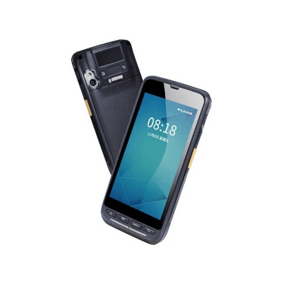**Price:** 2 pieces US$412.00

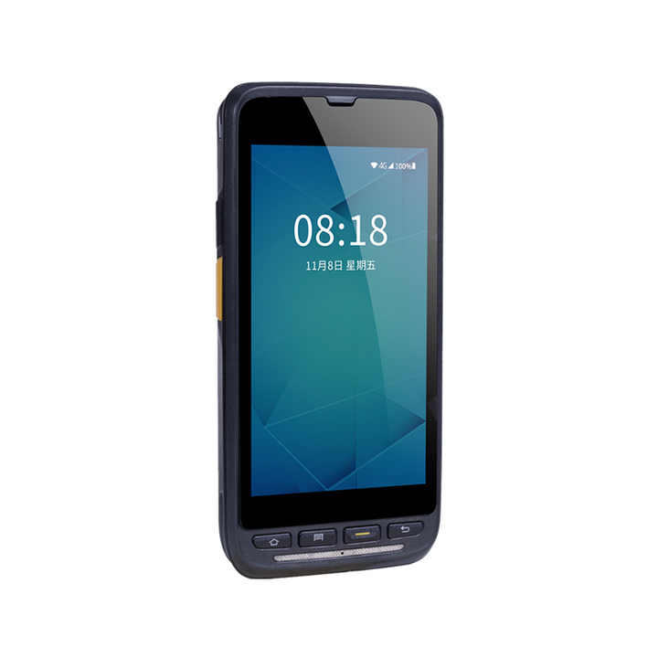

**Product Name:** GAOTek Inventory Scanning Gun PDA

**Product ID:** GAOTek-PERW-209

**Meta Description:** This Inventory Scanning Gun PDA has a battery of lithium battery of 3.85 V or 4000 mAh, display of 4.7inch and a expansion slot SD card up to 256 GB.

**Technical Specifications:**

|  |  |
| --- | --- |
| **Processor** | Octa-core 2.0 GHz |
| **Operating system** | Android 9.0 |
| **Memory (ROM+RAM)** | 16 GB+2 GB |
| **SIM** | Single SIM card |
| **Expansion slot** | Micro SD card, up to 256 GB |
| **Display screen** | 4.7inch, resolution: 1280 pixel x 720 pixel |
| **Touch screen** | Industrial capacitive screen, supporting two-point touch + gesture operation |
| **Camera** | 8 MP autofocus camera in the back side (13 MP optional), LED flash |
| **Flashlight** | 800mA flashlight |
| **Keyboard** | 9 keys in total, front key x 4, side scan x 2, side custom key x 2, side power key x 1 |
| **Battery** | Lithium battery 3.85 V or 4000 mAh, removable  x Executive standard: GB31241-2014 |
| **Audio** | Built-in microphone |
| **Charging** | Type-C charging and pin port charging, 18 W fast charging |
| **Prompts** | Vibration reminder or LED reminder or audio reminder |
| **Vibrating motor** | Built-in vibrating motor |
| **Sensor** | Gravity sensor (G-sensor) |
| **Wireless wide area network (Network frequency)** | Asia & Europe： 2G：B2/B3/B5/B8 3G：WCDMA：B1/B2/B5/B8，CDMA BC0，TD-SCDMA：B34/B39 4G：FDD-LTE：B1/B3/B7/B8/B20，TDD-LTE：B34/B38/B39/B40/B41 America： 2G: B2/B3/B5 3G: B1/B2/B4/B5，CDMA BC0/BC1 (America) 4G: B1/B2/B3/B4/B5/B7/B12/B17/B28A/B28B/B41 |
| **Wireless wide area network (Data service)** | GSM/GPRS/EDGE/CDMA/UMTS/HSPA/HSPA+/EVDO/WCDMA/TD-SCDMA/TDD-LTE/FDD-LTE |
| **WLAN** | Wi-Fi 802.11a/b/g/n/ac/r/d/e/h/i/j/k/v（2.4G+5G dual-band Wi-Fi）, fast roaming ,Wi-Fi 5G PA |
| **BT** | BT 5.0 |
| **GPS** | GPS or AGPS or Beidou or Galileo or GLONASS |
| **PSAM card** | Supporting |
| **Drop specification** | 59.6 in (1500 mm) marble floor dropped several times |
| **Protection level** | IP67 |
| **Electrostatic protection** | ±15 KV (air discharge), ±8KV (contact discharge) |
| **Humidity** | 0% to 95% (no condensation) |
| **Storage temperature** | -40 °F to 140 °F (-40 ℃ to 60 ℃)（Without battery） |
| **Working temperature** | -4 °F to 140 °F (-20 ℃ to 60 ℃) x For your safety, please do not charge in a low temperature environment |
| **Dimension** | 5.9 in x 2.8 in x 0.6 in (150 mm x 73.5 mm x 16 mm) |
| **Weight** | 0.58 lb (0.23 kg) |

<https://www.alibaba.com/product-detail/Unitech-EA520-Handheld-Data-Collector-Express_1600564378657.html?spm=a2700.galleryofferlist.normal_offer.d_title.36dc59abPAUBAG>

**Prices:** 2 to 9 pieces US$490.00

10 to 49 pieces US$485.00

>= 50 pieces US$480.00

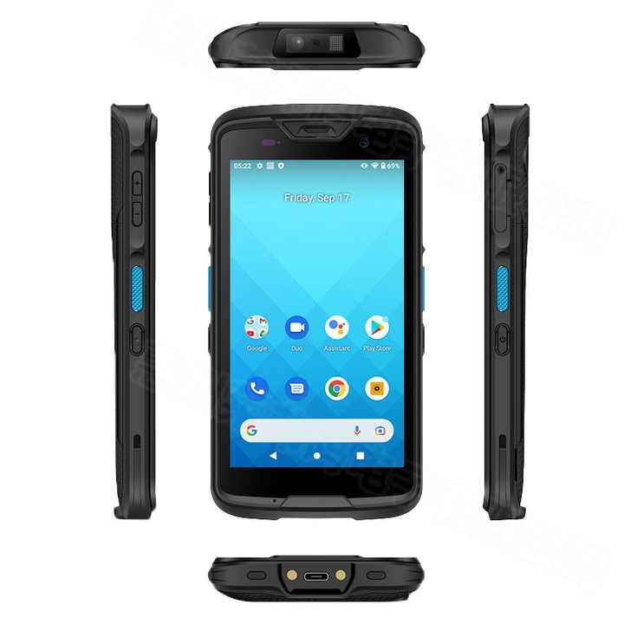

**Product Name:** GAOTek Handheld Data Collector

**Product ID:** GAOTek-PERW-2010

**Meta Description:** This Handheld Data Collector has a display of 5inch capacitive color multi touch screen, battery of 3.8 V or 4100 mAh and a CPU of 8-core(64 bit).

**Technical Specifications:**

|  |  |
| --- | --- |
| **operating system** | Google Android 11 (GMS certified) |
| **CPU** | 8-core (64 bit), 2.0 GHz processor |
| **Memory capacity** | ROM 64GB RAM 4GB |
| **Display / touch screen** | 5inch capacitive color multi touch screen, Resolution: 720 x 1280 (HD), Corning gorilla high-intensity touch screen, Support glove and wet finger operation mode |
| **Language** | Multi language support |
| **1D Barcode** | UPC or EAN or JAN, GS1 Data Bar, Code 39, Code128, Code 32, Code 93, Matrix 2 of 5, MSI, Coda bar or NW7, Interleaved 2 of 5 |
| **2D Barcode** | PDF417, MicroPDF417, GS1 Composite ,Code11, Aztec Code, Data Matrix, QR Code, MicroQR Code, Maxi Code |
| **Battery** | 3.8 V, 4100 mAH Lithium polymer battery |
| **IP level** | IP67 |
| **camera** | Rear lens: 13 million pixels (with auto focus and LED flash) Front lens: 8 million pixels |
| **Expansion slot** | MicroSD (up to 128GB) |
| **GPS** | AGPS, GPS, GLONASS, Beidou, Galileo |
| **wireless network** | IEEE 802.11a/b/g/n/ac, 2.4GHz and 5GHz Support 802.11d/e/h/i/j/k/r/v, fast roaming Wireless network security management mechanism WFA, WPA and WPA2 Support VoWiFi and hotspot sharing |
| **USB** | USB 2.0 (type-C) supports USB OTG |
| **Blue-tooth** | BT ® V5.0 |
| **Other sensors** | Accelerometer sensor, electronic compass, Gyro sensor, light sensor |
| **Scanner** | 2D image type, support DPM barcode reading It also has scanning indication (sound, vibration) function |
| **RFID** | Support HF frequency 13.56MHz NFC (near field communication) ISO14443 A/B, ISO15693, Felica(ISO/IEC18092) Mifare compliance |
| **Operating temperature** | -4 °F to 140 °F (-20 °C to 60 °C) |
| **Size** | 5.9 in x 3.09 in x 0.54 in (151.1 mm x 76.8 mm x 13.7 mm) |
| **Weight** | 0.56 lb (0.24 kg) (battery included) |

<https://www.alibaba.com/product-detail/Warehouse-Rf-Uhf-rfid-Pda-Vehicle_1600570386777.html?spm=a2700.galleryofferlist.normal_offer.d_title.36dc59abPAUBAG>

**Prices:** 2 to 99 pieces US$399.00

100 to 9999 pieces US$379.00

>= 10000 units US$369.00

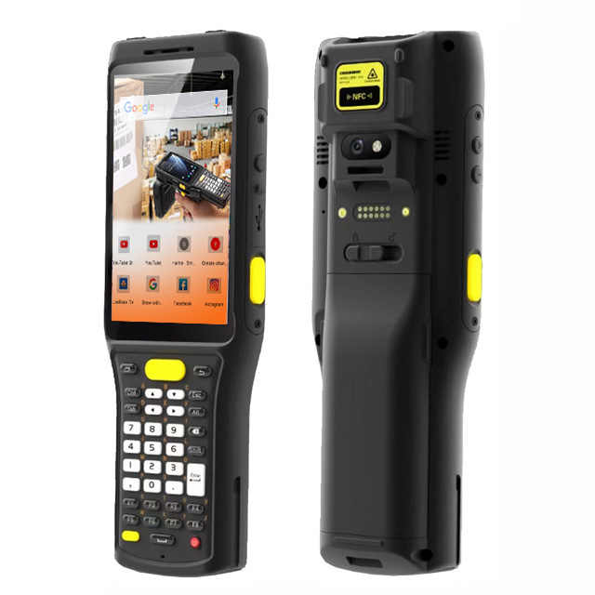 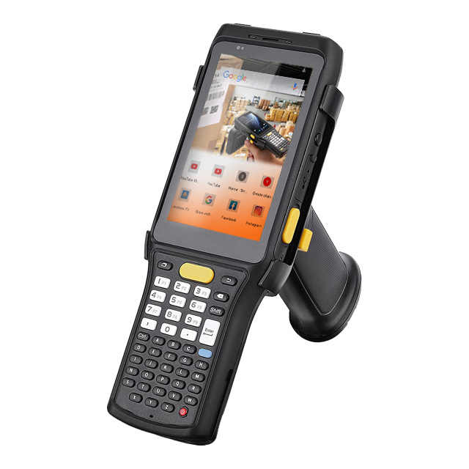

**Product Name:** GAOTek Hand Held Phone Android PDA

**Product ID:** GAOTek-PERW-2011

**Meta Description:** This Hand-Held Phone Android PDA has a display of 4inch high-definition, power of 6700 mAh and a frequency of 13.56 MHz ISO14443A or B, ISO15693.

**Technical Specifications:**

|  |  |
| --- | --- |
| **CPU** | Qualcomm2.0 GHz Octa-core |
| **RAM+ROM** | 3 GB + 32 GB or 4 GB + 64 GB |
| **Expansion** | Supports up to 128 GB Micro SD card |
| **Operating System** | Android 11.0GMS |
| **Network** | IEEE802.11 a/b/g/n/ac, 2.4 G / 5 G dual-band |
| **BT** | BT v5.1 |
| **GNSS** | GPS or AGPS, GLONASS, BeiDou; internal antenna |
| **Display** | 4inch high-definition display 800 x 480 |
| **Touch Panel** | Corning Gorilla Glass, multi-touch panel, gloves and wet hands supported |
| **Power** | Main battery: Li-ion, rechargeable, removable 6700 mAh |
| Standby: over 680 hours |
| **Expansion Slot** | 1 slot for Nano SIM card, 1 slot for SIM or TF card |
| **Interfaces** | USB 3.1 Type-C, OTG, Type-C headphones supported |
| **Key pad** | Main keyboard (Optional): 27 keys or 37 keys or 47 keys; Side keys: 2 SCAN keys + 2 volume keys + 1 user-defined key |
| **Sensors** | Gravity sensor, light sensor, proximity sensor, vibration motor |
| **2D barcode Scanner** | Zebra: SE4710 or SE4750 or SE4750MR or SE 4850 or Honeywell: N6603 or EX30(Option) |
| **Frequency** | 13.56 MHz ISO14443A or B, ISO15693, M1 or M3 card |
| **Engine** | CM710-1 module based on Impinj E710 CM2000-1 module based on Impinj Indy R2000 |
| **Frequency** | 865 MHz to 868 MHz or 920 MHz to 925 MHz or 902 MHz to 928 MHz |
| **Power** | 1 W (30 dBm, +5 dBm to +30 dBm adjustable) 2 W Optional (33 dBm, for Latin America, etc.) |
| **R/W ranges** | 590. 2 in (1500 mm) (open outdoors, Impinj MR6 tag) |
| **Dimensions** | 7.9 in x 2.8 in x 1.26 in (202 mm x 72.5 mm x 32.0 mm) (for standard version) |
| **Weight** | 0.66 lb (0.3 kg) |

<https://www.alibaba.com/product-detail/Handheld-Industrial-Rugged-Tablet-Android-11_1600952368402.html?spm=a2700.galleryofferlist.normal_offer.d_image.36dc59abPAUBAG>

**Prices**: 1 to 49 pieces US$280.00

50 to 99 pieces US$265.00

100 to 999 pieces US$260.00

>= 1000 units US$250.00

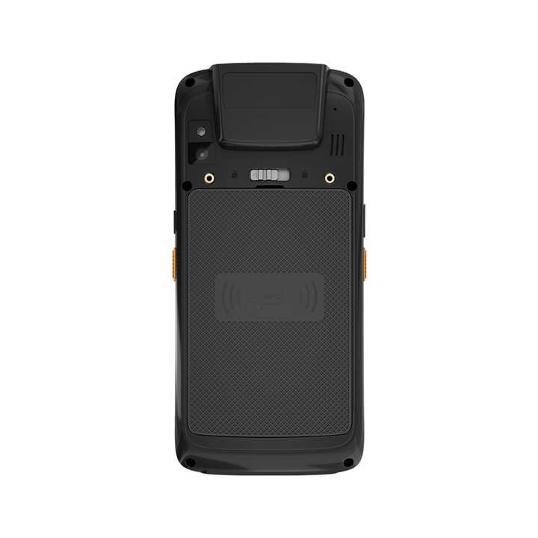 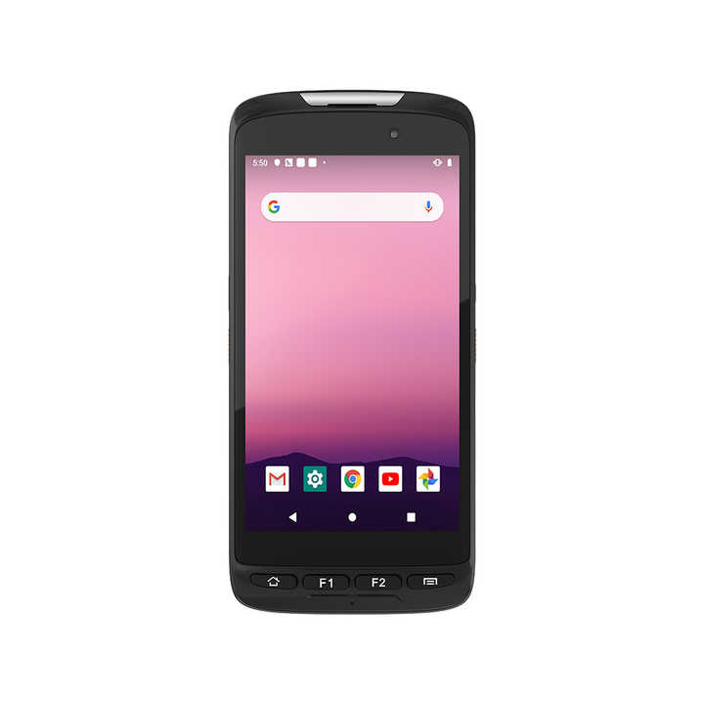

**Product Name:** GAOTek Handheld Industrial Rugged Tablet

**Product ID:** GAOTek-PERW-2012

**Meta Description:** This Handheld Industrial Rugged Tablet has a battery of 3.8 V or 4000 mAh, humidity of 95% non-condensing and a display of 5inch 720 x 1280.

**Features:**

* Android IP65 GPS Bluetooth
* Support for Android 11 system
* Optional 3G or 4G all network communication, Wi-Fi, Bluetooth and other communication modes
* Equipped with 4000mAh large capacity battery, the machine has a endurance of 10 hours
* IP65 high protection level, in accordance with MIL-STD-810G
* Support GPS, Glonass, Beidou(G+G+B), more accurate positioning
* Support front 5 million and rear 13 million pixel auto focus camera
* 2D, NFC and other functional modules to meet the application needs of multiple Industrial

**Technical Specifications:**

|  |  |
| --- | --- |
| **CPU** | MT6762 (8core) 4 x A53 2.0GHz 4 x A53 1.5GHz |
| **GPU** | IMG GE8320 650MHz |
| **Memory** | RAM: LPDDR4X up to 4GB(dual channels with 16-bit data bus width) ROM:64GB EMMC |
| **Operating System** | Andriod11 Optional: GMS |
| **Display** | Type: PS Size:5 inch 16:9 Resolution:720 x 1280 Brightness:350 Nit |
| **Touch Pannel** | 5 points Capacitive, G+FF |
| **Camera** | Front:5 MP Rear:13.0 MP, automatic focusing with astigmatism,PDAF support |
| **Speaker** | Embedded 8 Ω or 1 Speaker x 1 |
| **Microphone** | Sensitivity: -42db, Output Impedance:2.2kΩ |
| **Battery** | Built-in 3.8 V or 4000 mAh Removable Lithium-ion polymer battery 10.5hrs (50% volume sounds, 50% screen brightness,1080P HD video display by default) |
| **WIFI** | WIFI 802.11(a/b/g/n/ac) ,Frequency 2.4G+5G dual band WIFI, Support AP seamless roaming |
| **Bluetooth** | BT5.0(BLE) |
| **GPS** | Support GPS,Glonass,beidou(G+G+B) |
| **I/O Interface** | USB Type C x 1,OTG (Data transmission) |
| 3.5mm standard earphone jack x1 (US) |
| SIM card x 1 |
| TF card x 1 (SDHC/SDXC supported), Max:128GB |
| Pogo Pin (Base Charge) x 1 |
| **Adapter** | EU Standard DC 5V/2A |
| **USB cable** | USB Type C |
| **2D Barcode** | Scanner;Zebra4710 |
| **Humidity** | 95% non-condensing |
| **Working temperature** | 14 °F to 122 °F (-10 °C to 50 °C) |
| **Storage temperature** | -4 °F to 140 °F (-20 °C to 60 °C) |
| **Dimension** | 6.2 in x 2.9 in x 0.95 in (157.4 mm x 74.6 mm x 24.2 mm) |
| **Weight** | 0.57 lb (0.26 kg) |

<https://www.alibaba.com/product-detail/Industrial-Mobile-Android-PDA-Devices-Small_1600259602555.html?spm=a2700.galleryofferlist.normal_offer.d_title.36dc59ab3cO6x8>

**Prices:** 2 to 99 pieces US$285.00

100 to 499 pieces US$283.00

>= 500 pieces US$282.00

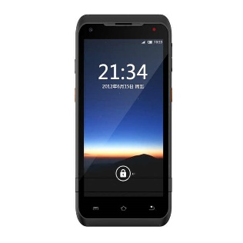 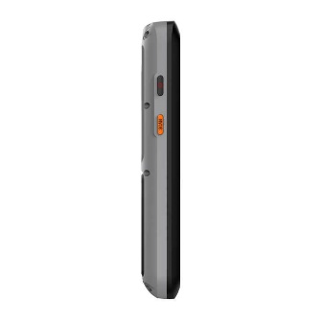

**Product Name:** GAOTek Industrial Mobile Android

**Product ID:** GAOTek-PERW-2013

**Overview:** GAOTek Industrial Mobile Android is a perfect Android PDA device to be used in warehouse, logistic, hospital etc. Its IP 66 protection standard includes dust-proof,1 meter water-proof and 1.2 meter drop-proof without damage. Suitable to use in extreme weather from -20 ℃ to 55 ℃ . It has 4500mAh large capacity battery, 5V/2A fast charging.

**Technical Specifications:**

|  |  |
| --- | --- |
| **memory** | RAM：DDR4 2GB（optional 3G/4GB/6GB) NandFlash：16GB（optional 32/64GB/128GB) |
| **Extend memory** | MicroSD or Tard slot(Max up to 128G) |
| **Display** | 5.5inch QVGA imitative glass durable touch screen, 720X1440 pixel, 350cd per ㎡ |
| **keyboard** | 5 keys, 3 touch function key |
| **battery** | 3.8 V 4500 mAh Rechargeable Li-polymer Battery |
| **camera** | 13MP, front camera 5MP（optional）, automatic focusing |
| **slot** | Micro Statfarad slot x 1, Micro SIM card slot x 1， PSAM card slot x 2 |
| **Light** | Battery light x 2 |
| **interface** | Type-C x 1, cradle charger interface |
| **Audio** | Speaker x 1, Microphone x 1, headphone x 1 |
| **Phone function** | Support HD voice mobile call |
| **Vibrating alert** | support |
| **compass** | support |
| **Audio decibel** | Louder speaker 90dB |
| **1D barcode** | SE955 or U966/N4313 Code 39, Coda bar, Code 128, Discrete 2 of 5, Interleaved 2 of 5, Code 93, UPC-A, UPC-E，EAN-8, EAN-13, MSI, EAN-128, ISBN/ISSN etc. |
| **2D QR code** | Imported Zebra 4710 1D:Code 39, Coda bar, Code 128, Discrete 2 of 5, Interleaved 2 of 5, Code 93, UPC-A，UPC-E, EAN-8, EAN-13, MSI, EAN-128, ISBN/ISSN etc. 2D：PDF417, QR Code(QR1, QR2, Micro QR), Data Matrix, GS1-DataBarTM(RSS-Limited, RSS-14, RSS-14 Stacked, RSS-Expand) etc. |
| **NFC（optional）** | ISO14443A, ISO15693, Mifare（support S50 & S70 card read and write） |
| **UHF RFID（optional）** | 2-3 meters distance for UHF reader |
| **Wi-Fi** | IEEE 802.11a/b/g/n/ac, support 2.4GHz, 5.0GHz |
| **BT** | BT 4.1 |
| **GPS** | Support GPS, Beidou |
| **IP rate** | IP66, 6 sides can bear impact from 1.5m drop to cement floor in the range of operating temperature |
| **accessories** | Type C charging cable x 1, battery x 1. |
| **Wireless communication** | FDD-LTE |
| **Environment Humidity** | 5 %RH to 95 %RH (no condensation |
| **Operating Temperature** | -4 °F to 131 °F (-20 °C to 55 °C) |
| **Storage Temperature** | -40 °F to 176 °F (-40 °C to 80 °C) |
| **size** | 6.8 in x 3.2 in 0.8 in (174 mm x 82 mm x 22 mm) |
| **weight** | 0.66 lb (0.3 kg) |